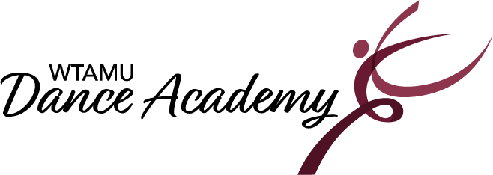
2024-2025 Important Dates

Classes Begin: August 26^{tt}, 2024.
Classes End & Last day to register/add a class: December 7th, 2024.
Classes Resume: January 6th, 2025.
Classes End: May 2nd, 2025.
Dress Rehearsal for Recital: May 3rd, 2025.
Recital: May 4th, 2025.
Installments due dates
August 26th, September 2nd , November 4th, December 2nd, February 3rd,
March 3rd and March 31st
Holidays/ No Classes:
September 2nd: Labor Day
November 25th – 29th: Thanksgiving Break
December 9th – January 5th: Winter Break
January 20th: Martin Luther King Jr. Day
March 10th – 14th: Spring Break
March 18th: Good Friday
*Registration is on-going until December 7th.

